**Neptune 2 series**

**Marlin configuration modification reference**

Currently, the Neptune2&2D have two types of main boards, including the ZNP Robin Nano V1.2 and ZNP Robin Nano V1.3. The Neptune2S uses ZNP Robin Nano V1.3 main board.

PS:Do not load wrong firmware onto the motherboard, it may damage the motherboard.

At present, the motherboards ZNP Robin Nano V1.2 and ZNP Robin Nano V1.3 support the latest marlin, which can be downloaded from the marlin official website.

Marlin URL：<https://marlinfw.org/meta/download/>

Original firmware URL：<https://www.elegoo.com/pages/3d-printing-user-support>

Note: Please confirm the motherboard model before compiling the firmware.

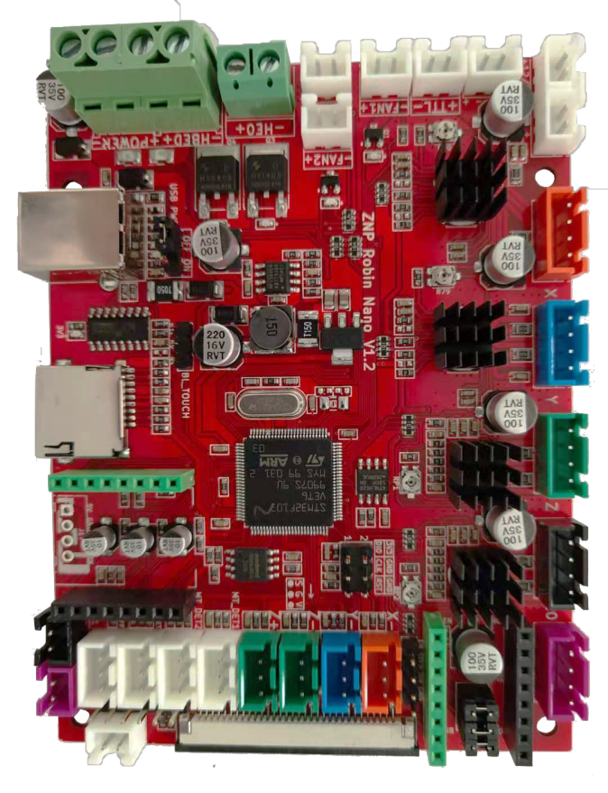

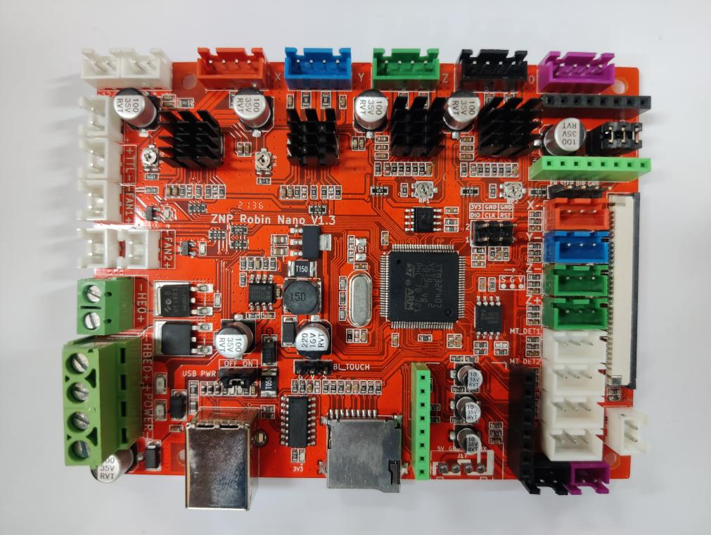

Configuration content:

The motherboard ZNP Robin Nano V1.2 can refer to Robin Nano V1.2

The motherboard ZNP Robin Nano V1.3 can refer to Robin Nano V1.3

Reference URL：<https://github.com/makerbase-mks/MKS-Robin-Nano-V1.X>

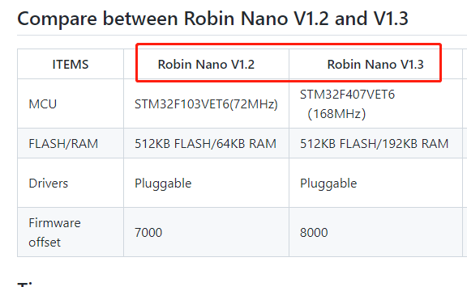

ZNP Robin Nano V1.2 and ZNP Nano V1.3 the pin map same as the MKS Robin Nano V1.2 .The pin diagram is shown below.

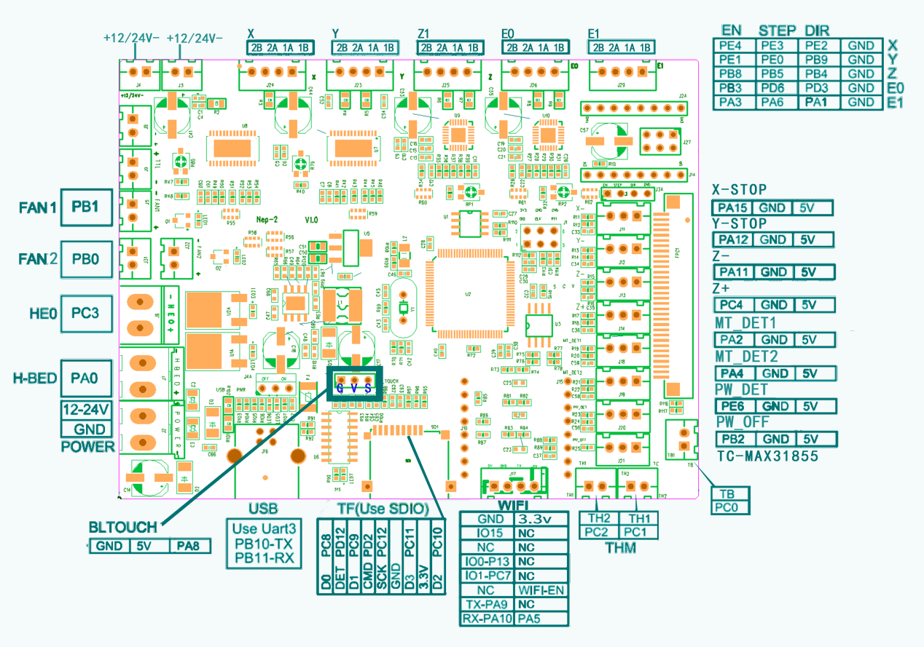

Please don’t update V1.2 version's firmware to V1.3 motherboard.

**ZNP Robin Nano V1.2 build and update firmware**

Build config:

platformio.ini:

default_envs = mks_robin_nano35

Configuation.h:

#define SERIAL_PORT 3

#define BAUDRATE 115200

#define MOTHERBOARD BOARD_MKS_ROBIN_NANO  
#define MKS_ROBIN_TFT35

#define TEMP_SENSOR_BED 1

#define SDSUPPORT

#define TFT_LVGL_UI

#define TOUCH_SCREEN

#define INVERT_X_DIR false

#define INVERT_Y_DIR false

#define INVERT_Z_DIR true

#define INVERT_E0_DIR false

#define INVERT_E1_DIR false

#define DEFAULT_AXIS_STEPS_PER_UNIT   { 80, 80, 400, 90 }

#define DEFAULT_MAX_FEEDRATE          { 150, 150, 6, 70 }

#define DEFAULT_MAX_ACCELERATION      { 1000, 1000, 100, 5000 }

#define X_BED_SIZE 235

#define Y_BED_SIZE 235

#define Z_MAX_POS 260

Configuation_adv.h:

#define E0_AUTO_FAN_PIN PB0  
//#define USB_FLASH_DRIVE_SUPPORT

//#define MULTI_VOLUME

ini\stm32f1.ini:

[env:mks_robin_nano35]

#board_build.rename          = Robin_nano35.bin Cancel this line

board_build.rename          = elegoo.bin Add this line

**Update firmware:**

* Enter the directory, copy the folder and to the TF card .pio\build\mks_robin_nano35\assets elegoo.bin
* Insert TF card to the motherboard, and you can see the update interface after power on.

**ZNP Robin Nano V1.3 build and update firmware**

Build config:

platformio.ini:

default_envs = mks_robin_nano_v1_3_f4

Configuation.h:

#define SERIAL_PORT 3

#define BAUDRATE 115200

#define MOTHERBOARD BOARD_MKS_ROBIN_NANO_V1_3_F4

#define MKS_ROBIN_TFT35

#define TEMP_SENSOR_BED 1

#define SDSUPPORT

#define TFT_LVGL_UI

#define TOUCH_SCREEN

#define INVERT_X_DIR false

#define INVERT_Y_DIR false

#define INVERT_Z_DIR true

#define INVERT_E0_DIR false

#define INVERT_E1_DIR false

#define DEFAULT_AXIS_STEPS_PER_UNIT   { 80, 80, 400, 90 }

#define DEFAULT_MAX_FEEDRATE          { 150, 150, 6, 70 }

#define DEFAULT_MAX_ACCELERATION      { 1000, 1000, 100, 5000 }

#define X_BED_SIZE 235

#define Y_BED_SIZE 235

#define Z_MAX_POS 260

Configuation_adv.h:

#define E0_AUTO_FAN_PIN PB0  
//#define USB_FLASH_DRIVE_SUPPORT

//#define MULTI_VOLUME

Ini\stm32f4.ini:

[env:mks_robin_nano_v1_3_f4]

#board_build.rename          = Robin_nano35.bin Cancel this line

board_build.rename          = elegoo.bin Add this line

**Update firmware:**

* Enter the directory, copy the folder and to the TF card .pio\build\mks_robin_nano_v1_3_f4\assets elegoo.bin
* Insert TF card to the motherboard, and you can see the update interface after power on.